EXP:1
IDENTIFY THE CURRENT SHELL AND LENGTH OF THE STRING
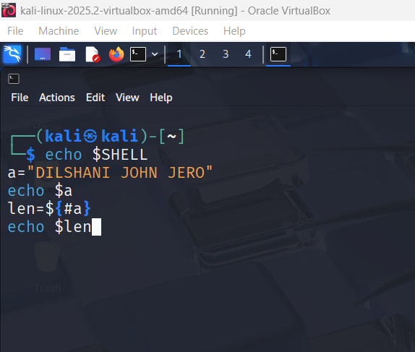
Output:
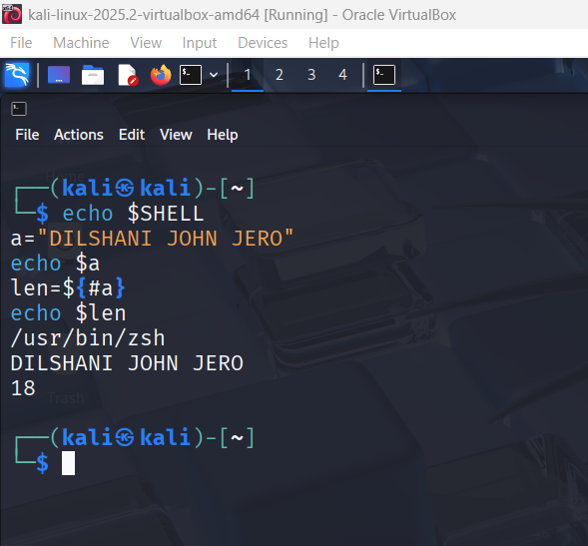
EXP: 2
COUNT BACKWARDS FOR 100 TO 0 USING FOR LOOP
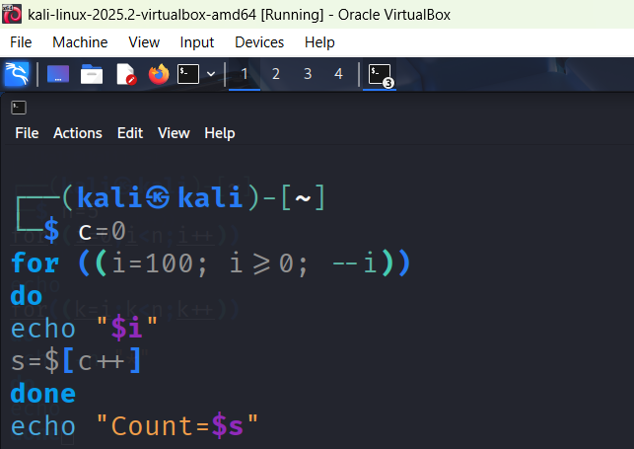
OUTPUT:
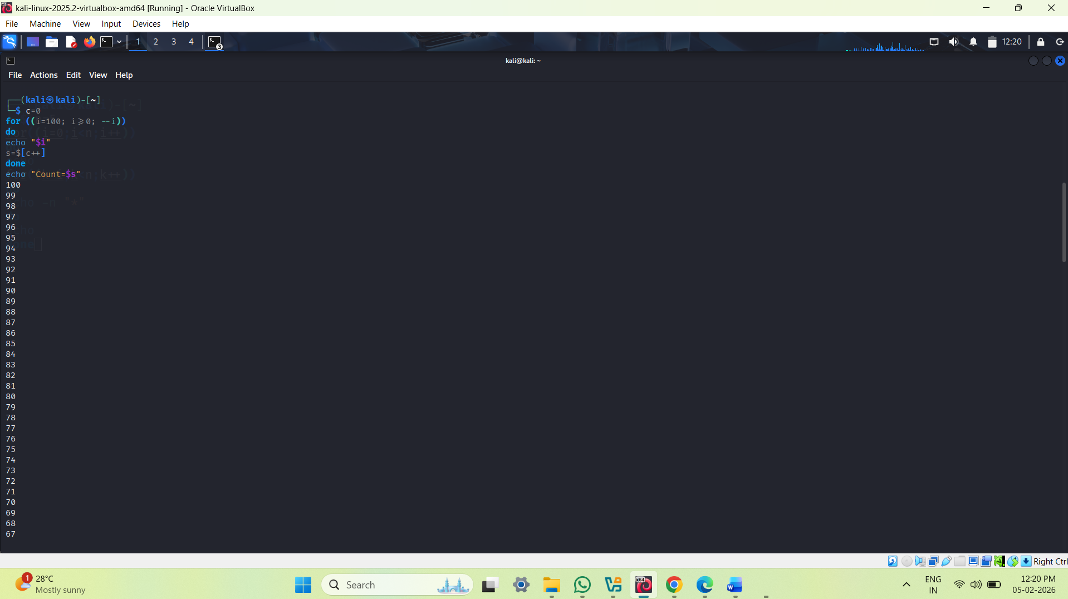
EXP:3
Print Star Pyramid Downwards
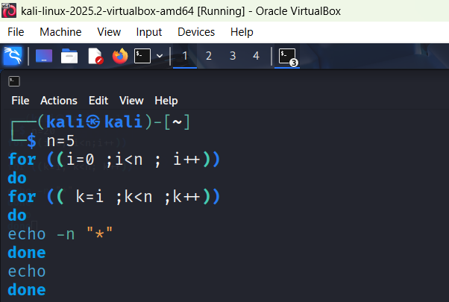

OUTPUT:
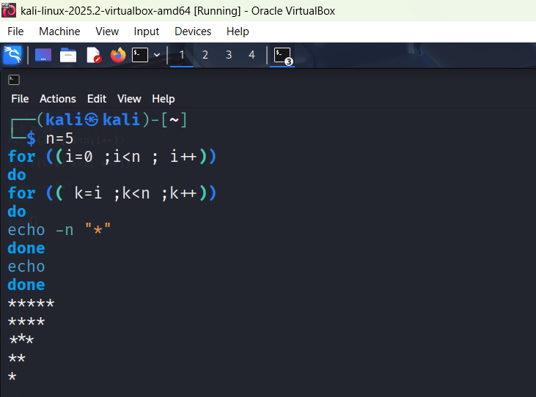
EXP:4
Print Odd/Even number + odd count/even count + odd sum/even sum
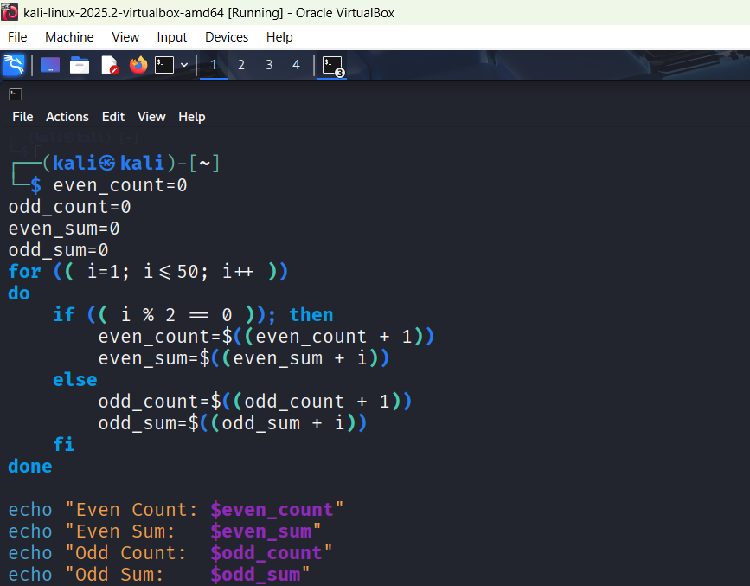
OUTPUT:
